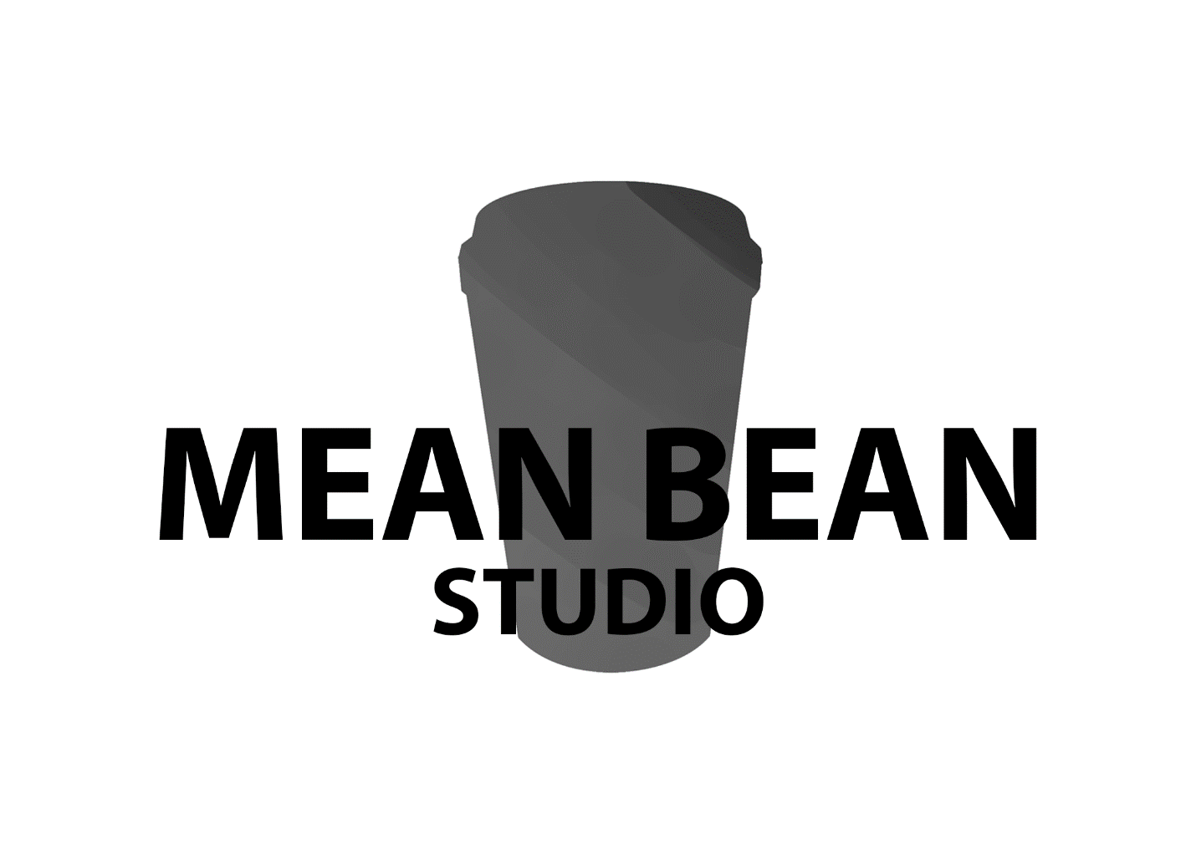

Luke, Will, Aiden, Domenic, Pasqual, Tarek

**Client synopsis**

The client has made it clear that the following needs to be in the game

1. The game should be
   1. Exciting
   2. Positive
   3. Upbeat
   4. Dynamic
2. The game should focus on
   1. Traveling
   2. Collecting experiences
3. End with an amazing cup of coffee

**Project scope**

Due to the amount of time the scope of the project will be small. Even though we have a team of six we are experimenting with new tasks such as map generation which will take time to make.

**Genre**

In terms of genre we decided to do a 3D endless runner. This fits within our projects scope and pushes our comfort zone.

Target platform \

Although we would like to make the game for the phone

Target market

Competitor analysis

Project approval process

**Aiden Thiele:**

**Skills:**

3D modelling (Proficient with Zbrush and Maya)

Texturing (Hand painted and done though substance painter)

Lighting (Creating lighting passes in engine)

Concepting (Proficient in creating rough sketches and concepts)

**Duties:**

Environment artist (Building and texturing assets for the levels)

Assisting with lighting or completing main lighting passes

Assistance with sound design

(Can work with animations in some scenarios)

**Responsibilities:**

I have the responsibility to ensure that environment art is up to par and that it serves the level design seamlessly.

I have a duty to create assets to the best of my ability to fulfill whatever request is presented.

I have a responsibility to serve the group to the fullest to ensure our success.

|  |  |
| --- | --- |
| Strength | Weakness |
| 3D modelling and sculpting | Character animation |
| Texturing of assets | Over scoping |
| Lighting environments | Trying to ensure things are perfect |
| Hard working | Can have self-destructive work habits |
| Quick learner | Can become distracted with new concepts |
| Able to problem solve | Will try and find the correct method to solve issues even if it can cost some extra time |

**Tarek Waleed:**

**Skills:**

3D modelling: Can make anything in Maya.

Animating: Can rig and animate in Maya

Texturing: Can texture models in substance painter

Concepting: Can do concepting in photoshop but I’m not the best at it

**Duties:**

Rigging and Animating

**Responsibilities:**

I have the responsibility to create rigs and animation without any errors

|  |  |
| --- | --- |
| Strength | Weakness |
| Maya | zbrush |
| Texturing | May lose motivation |
| Rigging and Animating | Tired almost everyday |
| Unity and Unreal engine | Not good with documents, especially very long ones |

**William Tjang**

**Skills**

* C++ programming
* C# programming
* Unity development

**Duties**

* Coding the tile/map generation function
* Coding a share of the player pickup mechanics
* Coding a local leaderboard generator

**Responsibilities**

* Create a script which endlessly generates tiles until the player dies and ensure that a set of rules are followed such it is always possible for the player to pass any point. E.g. Obstacles are not stacked together so that is impossible for the player to pass.
* Ensure each of the pickup mechanics work as intended.
* Create a code which saves the leaderboard onto a file that is stored locally on the player’s computer.

|  |  |
| --- | --- |
| Strength | Weakness |
| Coding mechanics | Coding complex AIs |
| Maths calculation | Documentation |
| Knowledge of Unity functions/features | Pre-planning |
| Debugging | Tendency to overscope |

**Domenic Nastasio**

**Skills:**

3D modelling (in Maya and Zbrush)

Texturing (in substance painter)

Concepting (hand drawing is my strongest)

**Duties:**

Work on character designs

Making sure there able to be used to be animated

**Responsibilities:**

I have the responsibilities of making sure the characters are spot on and how everyone envisioned of them.

Helping out with assets for the game so we can make sure we get done by the deadline.

|  |  |
| --- | --- |
| Strength | Weakness |
| 3D modelling and sculpting | Texturing |
| Zbrush and Maya | Skin weighting |

Pasqual Fletcher

Skills:

* C++ programming
* C# programming
* Unity development

Duties:

* The player character control scripts
* The Menu and user interface scripts
* Half the player pickups

Responsibilities:

* I have the responsibility to create the scripts to allow control of the players character, the scrips for the menu and UI as well as some of the pickups.
* I have the responsibility to ensure the player character is responsive and feels good to control. To make sure the menu, UI and character pickups work correctly.

|  |  |
| --- | --- |
| Strength | Weakness |
| Unity | Documentation |
| C# | AI |
|  |  |
|  |  |